Survey-Weighted Survival Analysis and Machine Learning Prediction of
Age at Male Circumcision in Cameroon

Written and presented
By
ENOW BRENDA & NANA IVANA

Abstract
Background: Voluntary medical male circumcision (VMMC) reduces HIV acquisition risk by up to 60%. However, program effectiveness depends critically on circumcision occurring before sexual debut. In Cameroon, suboptimal targeting may delay circumcision until after periods of highest HIV vulnerability, undermining prevention impact.
Objectives: To identify sociodemographic and behavioural determinants of age at circumcision using nationally representative survey data; to develop and compare classical survival and machine learning models for predicting individual-level circumcision timing; and to propose an interpretable decision-support framework for field-level risk stratification and resource allocation.
Methods: We analysed Cameroon Demographic and Health Survey (DHS) Men's Recode data (n = 6,551 after cleaning), incorporating complex survey weights, strata, and primary sampling units (PSUs). Classical methods included survey-weighted Kaplan-Meier estimation, log-rank tests, and Cox proportional hazards regression with Schoenfeld residual diagnostics. Machine learning approaches included Random Survival Forest (RSF), Gradient Boosting Survival Analysis (GBSA), XGBoost Cox, and XGBoost Accelerated Failure Time (AFT) models. Permutation importance and SHAP values were used for model interpretability. A deployable prediction function was constructed to return individual survival curves, median circumcision age, and risk categories.
Results: The weighted circumcision prevalence was 93.0%, with a median age at circumcision of 3 years. Log-rank tests indicated significant differences in circumcision timing across all examined covariates (p < 0.05). In multivariable Cox regression, higher wealth (richest vs. poorest: HR = 1.50, 95% CI: 1.21–1.87, p < 0.001), residence in the West (HR = 2.90, 95% CI: 2.18–3.85, p < 0.001), North-West (HR = 2.58, 95% CI: 2.03–3.28, p < 0.001), and South-West (HR = 2.43, 95% CI: 1.72–3.41, p < 0.001) regions, and weekly television exposure (HR = 1.27, 95% CI: 1.14–1.42, p < 0.001) were associated with earlier circumcision, whereas Animist religion (HR = 0.48, 95% CI: 0.34–0.67, p < 0.001) and older age groups were associated with later circumcision. The proportional hazards assumption was violated globally (p < 0.001). Among machine learning models, Gradient Boosting Survival Analysis achieved the best discrimination (C-index = 0.718; mean time-dependent AUC = 0.782; IBS = 0.067), followed closely by XGBoost Cox (C-index = 0.715). Region (grouped permutation importance = 0.143), wealth (0.043), and religion (0.014) were the dominant predictive features.
Conclusion: Both classical and machine learning approaches confirm that socioeconomic status, geography, and media exposure are critical determinants of circumcision timing. The developed prediction framework can stratify individual risk and guide targeted VMMC outreach to adolescents and young adults at highest risk of delayed circumcision, complementing population-level evidence with actionable, individual-level intelligence.
Keywords: male circumcision, survival analysis, machine learning, HIV prevention, Cox proportional hazards, gradient boosting

1. Introduction
Voluntary medical male circumcision (VMMC) is a cornerstone of HIV prevention in sub-Saharan Africa, with evidence demonstrating up to 60% reduction in female-to-male HIV transmission risk. Despite substantial investment in national VMMC campaigns, high HIV incidence persists among adolescent and young adult populations in several priority countries. A growing body of evidence suggests that the problem is not merely whether men are circumcised, but when circumcision occurs. Delayed circumcision extends the "vulnerability window" during which individuals are exposed to HIV before acquiring the protective benefits of the procedure.
Traditional binary classification approaches predicting circumcised versus uncircumcised status at a single point in time fail to capture this temporal dimension. Two 12-year-old boys may both be currently uncircumcised, yet one may undergo the procedure at age 13 while the other delays until age 19. A classification model treats both identically; a survival model distinguishes them, enabling targeted intervention for the boy with the longer vulnerability window.
This project therefore adopts a two-phase analytical strategy. Phase 1 applies classical survey-weighted survival analysis to establish the epidemiological evidence base: estimating population-level circumcision timing, identifying statistically significant disparities across subgroups, and quantifying adjusted associations through Cox regression. Phase 2 deploys machine learning survival models to maximise individual-level predictive accuracy and build a deployable risk-stratification tool. The integration of both phases yields a decision-support system that speaks simultaneously to policymakers who need population comparisons and field officers who need individual risk profiles.
We illustrate this framework using Cameroon DHS Men's Recode data, which provides nationally representative information on male circumcision status, age at circumcision, and a rich set of sociodemographic and behavioural covariates.

2. Objectives of the study
- To estimate the distribution of age at circumcision and identify population subgroups with delayed circumcision using nationally representative, survey-weighted DHS data for Cameroon.
- To quantify associations between sociodemographic, economic, behavioural, and geographic factors and circumcision timing, while accounting for the complex DHS sampling design.
- To develop, validate, and compare classical and machine learning survival models for predicting individual-level circumcision timing.
- To construct an interpretable, deployable risk-stratification tool that returns survival curves, median predicted circumcision age, and actionable risk categories for program targeting.

3. Methodology

3.1 Data Source and Study Population
The analysis used the Cameroon Demographic and Health Survey (DHS) Men's Recode dataset (file CMMR71FL). DHS surveys employ stratified multistage cluster sampling; consequently, all analyses incorporated primary sampling units (PSUs), stratification identifiers, and normalized sampling weights to ensure nationally representative estimates and valid standard errors.

3.2 Variables

3.2.1 Dependent (Outcome) Variables
Survival analysis generally requires two types of variables the event variable and the time variable .In response to this and the study in question , the dependent variables selected were
- Age at circumcision (MV483A)
- Circumcision Status (MV483)

3.2.2 Independent (Predictor) Variables
The following variables were selected as target features or independent variables:
Variable | Description / Categories | Type
Age group (MV012) | 15–24, 25–34, 35–44, 45–54, 55+ | Categorical
Residence (MV025) | Urban, Rural | Nominal
Education (MV106) | No education, Primary, Secondary, Higher | Ordinal
Wealth index (MV190) | Poorest, Poorer, Middle, Richer, Richest | Ordinal
Marital status (MV501) | Never in union, Married, Living with partner, Widowed, Divorced, Separated | Nominal
Religion (MV130) | Catholic, Protestant, Other Christians, Muslim, Animist, None, Other | Nominal
Region (MV024) | Adamawa, Centre (without Yaounde), Douala, East, Far-North, Littoral (without Douala), North, North-West, West, South, South-West, Yaounde | Nominal
Television exposure (MV159) | Not at all, Less than once a week, At least once a week | Ordinal
Radio exposure (MV158) | Not at all, Less than once a week, At least once a week | Ordinal
HIV testing (MV781) | Ever tested (Yes), Never tested (No) | Nominal
Current age (mv012) | Continuous (years) | Numeric
Table 1: Independent variables included in the analysis

3.2.3 Survey Design Variables
- Sample weight (weight_norm): DHS sample weight divided by 1,000,000.
- Primary Sampling Unit (PSU): Cluster identifier (MV021).
- Strata: Stratification identifier (MV022).

3.3 Data Cleaning and Survival Variable Construction
Data preparation for both the statistical and machine learning approach followed the analytical guidelines below:
- Respondents with unknown circumcision status (code 8) were excluded (n = 20 removed).
- Unknown age at circumcision (code 98) was recoded to missing; these respondents were retained in the survival dataset as censored observations at current age.
- Responses indicating circumcision before age 5 (code 95) were recoded to 2 years in the primary analysis; a sensitivity analysis excluded these observations.
- Survival times of 0 were adjusted to 0.25 years (3 months) to accommodate model requirements.
- Categorical variables were converted to factors with appropriate level ordering.

3.4 Phase 1: Classical Statistical Analysis method
To ensure the findings accurately represent the national population, we first structured the data to account for the complex way the survey was collected considering geographic groupings, regional divisions, and individual sampling weights. We then calculated weighted percentages to describe the demographic makeup of the study group.
To understand the typical age at which circumcision occurs, we used survival analysis techniques, which estimate the likelihood that a person remains uncircumcised at each age. We produced these age-progression curves for the whole sample and separately for groups based on where they live, their education, wealth, religion, and region. From these curves, we identified the median age and the middle range (25th to 75th percentiles) of circumcision timing.
To test whether different subgroups experience circumcision at significantly different ages, we performed statistical comparisons that yield p-values where smaller values indicate stronger evidence of real differences.
Next, we examined how various personal and social factors influence the timing of circumcision, both individually and all together in a single model. We expressed these results as hazard ratios: a number greater than 1 means earlier circumcision, while a number less than 1 means later circumcision, each with a 95% confidence interval showing the range of plausible values.
We also checked the underlying assumptions of our models to ensure reliability, using residual plots to detect any unusual patterns or extreme cases none of which were excluded, as they reflect real-world diversity.
Finally, we tested the stability of our conclusions by comparing two different approaches to handling uncertain or missing circumcision ages, and found that our main results remained consistent regardless of the approach used.

3.5 Phase 2: Machine Learning Survival Analysis

3.5.1 Preprocessing and Train-Test Split
- Data split: The dataset was partitioned into 80% training and 20% test sets to allow for internal validation.
- Encoding categorical variables: Nominal variables including residence, marital status, religion, region, and HIV testing history were one-hot encoded into binary indicator variables.
- Standardizing ordered and numeric variables: Ordinal factors (education, wealth, TV and radio exposure) and continuous measures (current age) were standardized to a common scale to ensure equitable contribution across features.
- Structuring the outcome: The circumcision event and age were formatted as a survival object (event indicator + continuous time), suitable for time-to-event analysis

3.5.2 Models
The following models were choosen to be trained based on the study objective which was to be able to model the survival function of an individual based on the features.
Model | Algorithm / Key Hyperparameters
RSF | Random Survival Forest; 300 estimators, min_samples_split=10, min_samples_leaf=15
GBSA | Gradient Boosting Survival Analysis; CoxPH loss, lr=0.05, 150 estimators, max_depth=5, subsample=0.8, early stopping
XGB-Cox | XGBoost with survival:cox objective; 150 estimators, max_depth=6, event-weighted sampling (weight=2.0 for events)
XGB-AFT | XGBoost with survival:aft objective; normal loss distribution, 200 boost rounds
Table 2: Machine learning models implemented and compared
- Performance metrics: Model performance was assessed using:
  - Concordance Index (C-index): Measures how well the model ranks individuals by their predicted circumcision timing (0.5 = random, 1.0 = perfect).
  - Time-dependent AUC: Evaluates discriminatory power at specific time quantiles.
  - Integrated Brier Score (IBS): Assesses calibration of predicted survival probabilities over time; lower values indicate better fit.
- Interpretability methods: To understand which factors most influence predictions, we calculated permutation importance measuring the drop in C-index when each variable was randomly shuffled.
4. Results

4.1 Descriptive Statistics
After data cleaning, the final analytical sample comprised 6,551 respondents. Table 1 presents weighted descriptive statistics, including the distribution of circumcision status (Yes/No) for each sociodemographic characteristic.
Characteristic | Not Circumcised (N = 4,89) | Circumcised (N = 6,451)
Age group
15–24 | 203 (42%) | 2,445 (38%)
25–34 | 123 (25%) | 1,645 (25%)
35–44 | 76 (16%) | 1,176 (18%)
45–54 | 55 (11%) | 734 (11%)
55+ | 31 (6.4%) | 465 (7.2%)
Residence
Urban | 130 (27%) | 3,709 (57%)
Rural | 358 (73%) | 2,756 (43%)
Education
No education | 89 (18%) | 715 (11%)
Primary | 174 (36%) | 1,660 (26%)
Secondary | 213 (43%) | 3,353 (52%)
Higher | 13 (2.7%) | 738 (11%)
Wealth index
Poorest | 277 (57%) | 796 (12%)
Poorer | 78 (16%) | 1,205 (19%)
Middle | 61 (12%) | 1,384 (21%)
Richer | 36 (7.3%) | 1,428 (22%)
Richest | 38 (7.7%) | 1,653 (26%)
Marital status
Never in union | 245 (50%) | 3,098 (48%)
Married | 215 (44%) | 2,249 (35%)
Living with partner | 11 (2.2%) | 803 (12%)
Widowed | 0 (0%) | 50 (0.8%)
Divorced | 7 (1.4%) | 26 (0.4%)
Separated | 11 (2.3%) | 239 (3.7%)
Religion
Catholic | 136 (28%) | 2,541 (39%)
Protestant | 111 (23%) | 1,580 (24%)
Other Christians | 23 (4.8%) | 366 (5.7%)
Muslim | 76 (16%) | 1,602 (25%)
Animist | 129 (26%) | 133 (2.0%)
None | 12 (2.5%) | 204 (3.1%)
Other | 1 (0.3%) | 40 (0.6%)
Region
Adamawa | 4 (0.8%) | 293 (4.5%)
Centre (without Yaounde) | 11 (2.3%) | 835 (13%)
Douala | 51 (10%) | 841 (13%)
East | 5 (1.0%) | 395 (6.1%)
Far-North | 307 (63%) | 668 (10%)
Littoral (without Douala) | 5 (1.1%) | 297 (4.6%)
North | 61 (12%) | 811 (13%)
North-West | 10 (2.0%) | 337 (5.2%)
West | 12 (2.5%) | 698 (11%)
South | 6 (1.2%) | 381 (5.9%)
South-West | 4 (0.9%) | 136 (2.1%)
Yaounde | 12 (2.5%) | 772 (12%)
TV exposure
Not at all | 357 (73%) | 2,341 (36%)
Less than once a week | 64 (13%) | 1,022 (16%)
At least once a week | 69 (14%) | 3,103 (48%)
Radio exposure
Not at all | 346 (71%) | 2,911 (45%)
Less than once a week | 58 (12%) | 1,614 (25%)
At least once a week | 85 (17%) | 1,940 (30%)

Table 3. Weighted descriptive statistics of the study population with circumcision status distribution (n = 6,551)
The weighted prevalence of male circumcision was 93.0%. Most respondents were aged 15–24 years (38.1%), resided in urban areas (55.2%), had secondary education (51.3%), and 57.6% had ever been tested for HIV. Notable variations in circumcision prevalence were observed across subgroups: the Animist subgroup had the lowest circumcision rate (78.3%), while the West (97.2%) and North-West (96.8%) regions had the highest rates. The poorest wealth quintile also showed a lower circumcision rate (89.2%) compared to the richest (95.6%).

4.2 Age at Circumcision
Among circumcised men, the mean age at circumcision was 4.8 years (SD = 4.16), while the median age was 3 years. The distribution ranged from 0 to 40 years. The marked right skew indicates that the majority of circumcisions occur during early childhood, with a smaller proportion occurring at older ages.
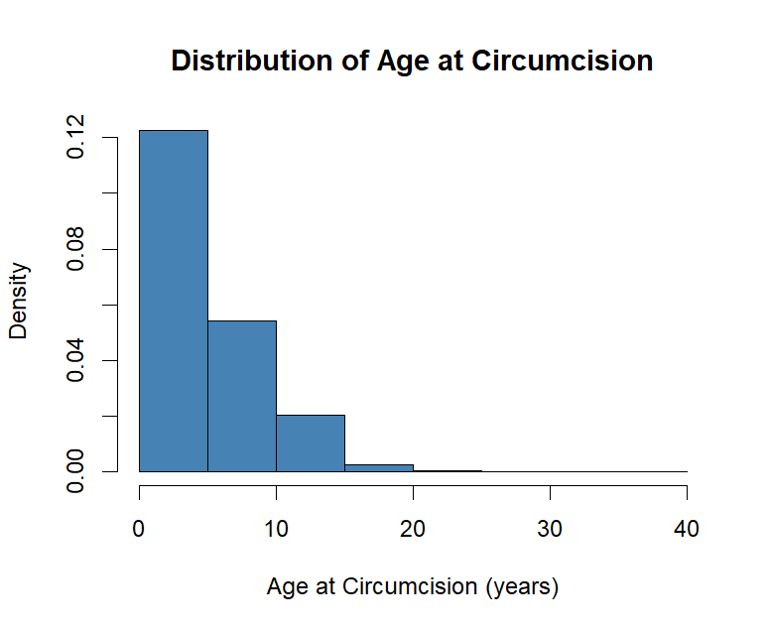
Figure 1: Distribution of Age at Circumcision (Histogram with Density Curve)

4.3 Kaplan-Meier Survival Analysis
The overall DHS-weighted Kaplan-Meier survival curve showed a sharp decline during early childhood, indicating a high rate of circumcision at young ages. The estimated median age at circumcision was 4 years, with 25% of males circumcised by age 2 and 75% circumcised by age 9. The subsequent plateau suggests relatively few circumcisions occur during adolescence and adulthood.
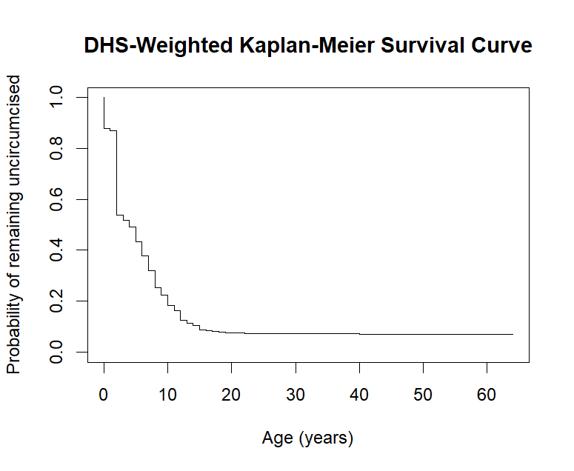
Figure 2: Overall DHS-Weighted Kaplan-Meier Survival Curve

4.3.1 Stratified Kaplan-Meier Curves by Key Predictors
Stratified Kaplan-Meier curves were estimated for each categorical predictor to assess differences in circumcision timing across subgroups. Below are the different results gotten from the interpreting the Kaplan-Meier curve for each sub-group.
(a) Region:
The most pronounced differences were observed across regions. The Far-North region showed the most delayed circumcision (highest survival probabilities), while the West, North-West, and South-West regions showed the earliest circumcision patterns (lowest survival probabilities). The log-rank test was highly significant (p < 0.001).

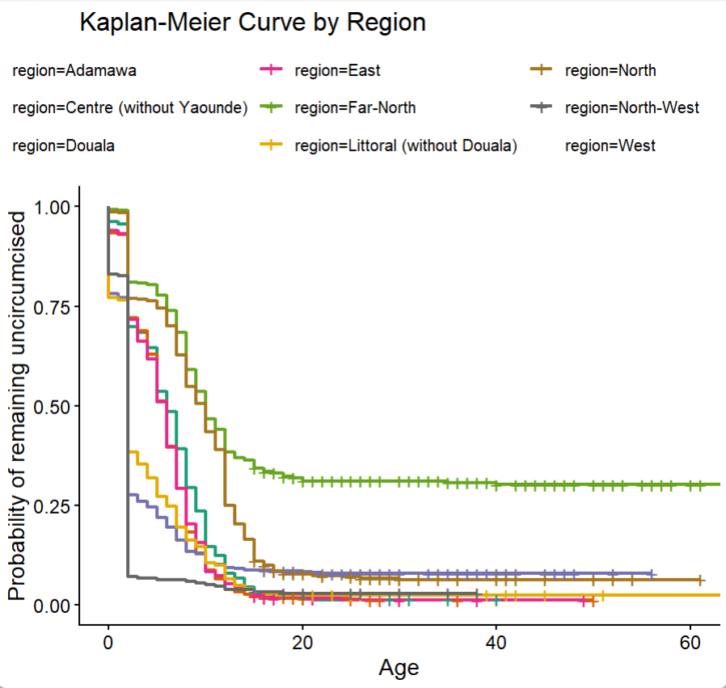
Figure 3: Kaplan-Meier Curves by Region
(b) Education Level:
Clear separation was observed across education levels, with men having no education showing earlier circumcision patterns compared to those with higher education. The log-rank test was highly significant (p < 0.001).
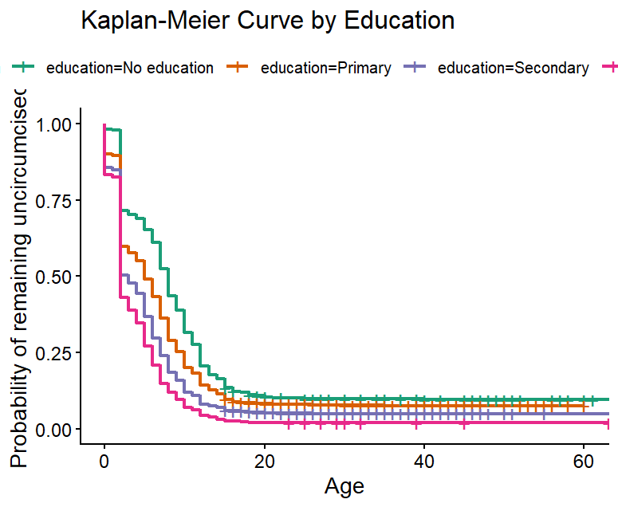
Figure 4: Kaplan-Meier Curves by Education
(c) Wealth Index:
A dose-response pattern was evident, with progressively wealthier quintiles showing earlier circumcision (steeper survival curve decline) compared to the poorest quintile. The log-rank test was highly significant (p < 0.001).
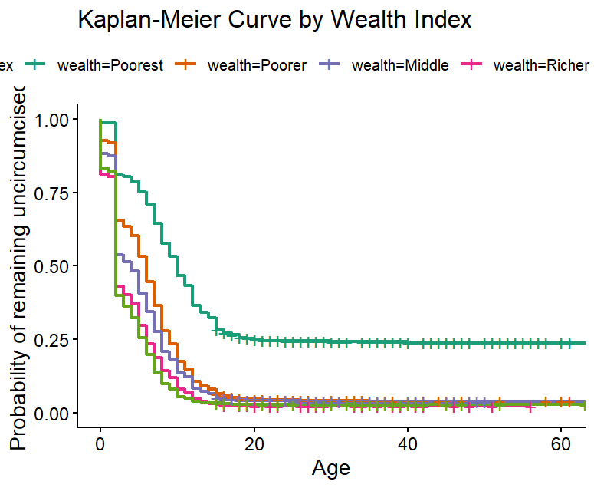
Figure 5: Kaplan-Meier Curves by Wealth Index

(d) Residence (Urban vs. Rural):
Urban and rural curves showed modest differences in early childhood, with rural areas exhibiting slightly delayed circumcision in some age ranges. The log-rank test was highly significant (p < 0.001).
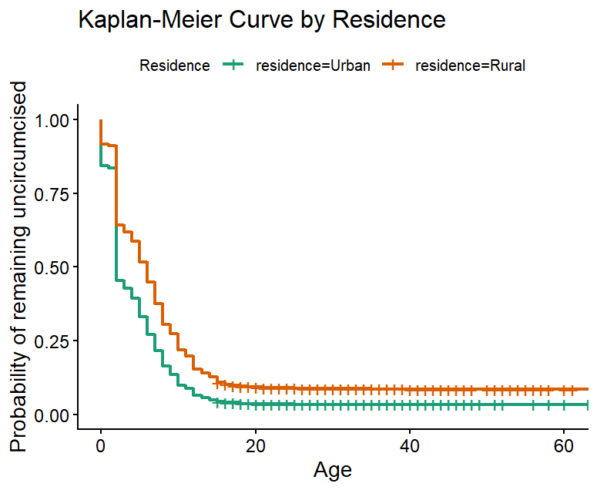
Figure 6: Kaplan-Meier Curves by Residence
(e) Religion:
Animist respondents showed markedly delayed circumcision compared to all other religious groups, with their survival curve remaining substantially above other groups across all ages. The log-rank test was highly significant (p < 0.001).
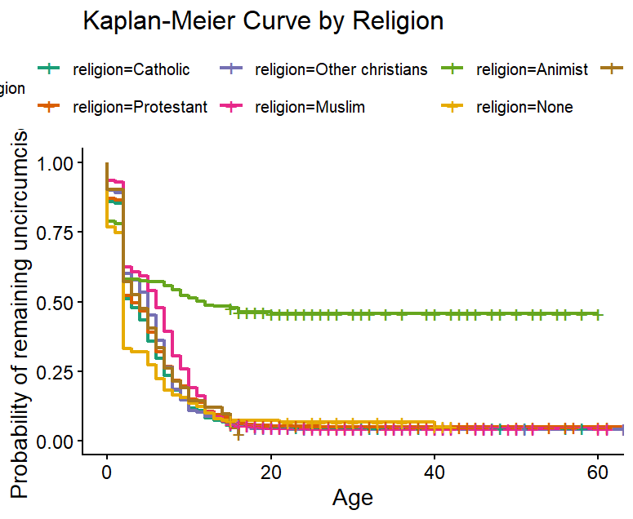
Figure 7: Kaplan-Meier Curves by Religion
(f) Marital Status:
Differences in circumcision timing were observed across marital status categories, with those living with a partner showing earlier circumcision patterns. The log-rank test was highly significant (p < 0.001).

4.4 Log-Rank Tests
Log-rank tests were conducted to assess whether circumcision timing differed significantly across levels of each categorical predictor. The results are presented in Table 2.
Variable | χ² (approx) | df | P-Value
Age group | 10.7 | 4 | 0.030
Residence | 286 | 1 | < 0.001
Education | 288 | 3 | < 0.001
Wealth index | 889 | 4 | < 0.001
Marital status | 127 | 5 | < 0.001
Religion | 240 | 6 | < 0.001
Region | 1717 | 10 | < 0.001
TV exposure | 660 | 2 | < 0.001
Radio exposure | 210 | 2 | < 0.001
HIV testing | 192 | 1 | < 0.001
Table 4. Log-rank test results for differences in circumcision timing across covariates
All ten predictors showed statistically significant differences in circumcision timing at the α = 0.05 level. The age group variable showed the weakest association (p = 0.030), while all other variables showed highly significant associations (p < 0.001). These findings indicate that circumcision timing varies significantly across virtually all sociodemographic, geographic, and behavioral subgroups examined, justifying the inclusion of all variables in the multivariable model.

4.5 Cox Proportional Hazards Regression

4.5.1 Univariable Models
Each predictor was examined separately (results available in Appendix). All variables except some education and marital status categories showed significant unadjusted associations with circumcision timing.
Summary of Key patterns
- Socioeconomic factors (education and wealth) showed strong, consistent gradients more education and greater wealth were both linked to earlier circumcision.
- Geography mattered substantially, with rural residence and several northern regions associated with later timing, while urban areas and most southern/western regions linked to earlier timing.
- Media exposure particularly television was strongly associated with earlier circumcision.
- Religion and marital status also played important roles, reflecting cultural and social influences on circumcision practices

4.5.2 Multivariable Model
Table 3 presents adjusted hazard ratios from the survey-weighted multivariable Cox model. Reference categories: age 15–24, urban residence, no education, poorest wealth, never in union, Catholic religion, Adamawa region, no media exposure, and no HIV testing.
Predictor | HR (95% CI) | p-value | Interpretation
Age group (Ref: 15–24)
25–34 | 0.83 (0.75 – 0.93) | 0.001 | Later circumcision
35–44 | 0.84 (0.75 – 0.94) | 0.002 | Later circumcision
45–54 | 0.85 (0.74 – 0.98) | 0.025 | Later circumcision
55+ | 0.75 (0.63 – 0.88) | < 0.001 | Later circumcision
Residence (Ref: Urban)
Rural | 0.97 (0.84 – 1.10) | 0.604 | Not significant
Education (Ref: No education)
Primary | 0.79 (0.69 – 0.90) | < 0.001 | Later circumcision
Secondary | 0.90 (0.78 – 1.03) | 0.138 | Not significant
Higher | 0.99 (0.83 – 1.19) | 0.913 | Not significant
Wealth (Ref: Poorest)
Poorer | 1.32 (1.12 – 1.56) | < 0.001 | Earlier circumcision
Middle | 1.28 (1.07 – 1.52) | 0.007 | Earlier circumcision
Richer | 1.44 (1.17 – 1.77) | < 0.001 | Earlier circumcision
Richest | 1.50 (1.21 – 1.87) | < 0.001 | Earlier circumcision
Marital status (Ref: Never in union)
Married | 1.02 (0.91 – 1.13) | 0.786 | Not significant
Living with partner | 1.20 (1.07 – 1.35) | 0.003 | Earlier circumcision
Widowed | 1.05 (0.77 – 1.42) | 0.755 | Not significant
Divorced | 0.53 (0.28 – 1.01) | 0.054 | Marginally later
Separated | 0.99 (0.83 – 1.18) | 0.915 | Not significant
Religion (Ref: Catholic)
Protestant | 0.98 (0.89 – 1.08) | 0.633 | Not significant
Other Christians | 0.94 (0.82 – 1.08) | 0.375 | Not significant
Muslim | 1.02 (0.89 – 1.17) | 0.776 | Not significant
Animist | 0.48 (0.34 – 0.67) | < 0.001 | Much later
None | 1.17 (0.94 – 1.45) | 0.163 | Not significant
Other | 0.59 (0.33 – 1.07) | 0.082 | Marginally later
Region (Ref: Adamawa)
Centre (w/o Yaounde) | 1.12 (0.90 – 1.39) | 0.298 | Not significant
Douala | 1.38 (1.04 – 1.84) | 0.026 | Earlier circumcision
East | 1.11 (0.92 – 1.35) | 0.267 | Not significant
Far-North | 0.51 (0.40 – 0.64) | < 0.001 | Much later
Littoral (w/o Douala) | 1.48 (1.17 – 1.87) | 0.001 | Earlier circumcision
North | 0.74 (0.62 – 0.88) | 0.001 | Later circumcision
North-West | 2.58 (2.03 – 3.28) | < 0.001 | Much earlier
West | 2.90 (2.18 – 3.85) | < 0.001 | Much earlier
South | 1.31 (1.07 – 1.60) | 0.010 | Earlier circumcision
South-West | 2.43 (1.72 – 3.41) | < 0.001 | Much earlier
Yaounde | 1.17 (0.93 – 1.47) | 0.174 | Not significant
TV exposure (Ref: Not at all)
Less than once a week | 1.04 (0.92 – 1.18) | 0.505 | Not significant
At least once a week | 1.27 (1.14 – 1.42) | < 0.001 | Earlier circumcision
Radio exposure (Ref: Not at all)
Less than once a week | 1.02 (0.93 – 1.12) | 0.649 | Not significant
At least once a week | 0.99 (0.89 – 1.10) | 0.889 | Not significant
HIV testing (Ref: No)
Yes | 1.04 (0.96 – 1.13) | 0.376 | Not significant

Table 5. Adjusted hazard ratios from the multivariable survey-weighted Cox model (Analysis A)
The model demonstrated good discrimination with a concordance statistic of approximately 0.74.
Key findings:
- Wealth showed a strong monotonic dose-response, with the richest quintile having 50% higher hazard than the poorest.
- Region showed the most dramatic differences, with West (HR = 2.90), North-West (HR = 2.58), and South-West (HR = 2.43) showing much earlier circumcision, while Far-North (HR = 0.51) showed much later circumcision.
- Animist religion was associated with a 52% lower hazard.
- Weekly television exposure was associated with a 27% higher hazard.
- Residence, radio exposure, and HIV testing were not significant after adjustment.

We checked the underlying assumptions of our Cox regression model and found some violations, meaning the influence of certain factors on circumcision timing may change slightly as men age a limitation we acknowledge given our focus on identifying associated factors rather than making precise predictions. Model fit checks showed the data were generally well represented, with only about 1% of individuals showing unusual patterns that were retained as reflecting real-world diversity.
To ensure our conclusions were robust, we compared two approaches for handling a small number of men circumcised before age 2 one including them and one excluding them. Our core findings, especially the strong associations with region, age, and wealth, remained consistent across both approaches, while a few secondary factors showed some sensitivity. Overall, we are confident that our main conclusions are stable and not driven by analytical choices.

4.6 Machine Learning Model Comparison
Table 4 summarises the predictive performance of the four machine learning survival models on the held-out test set.
Rank | Model | C-Index | Mean AUC | IBS | Status
1 | GBSA | 0.7179 | 0.7818 | 0.0668 | Success
2 | XGB-Cox | 0.7153 | 0.7768 | NaN | Success
3 | RSF | 0.6028 | 0.6567 | 0.0647 | Success
4 | XGB-AFT | 0.2884 | 0.2272 | NaN | Success
Table 6. Machine learning survival model comparison on the test set
The Gradient Boosting Survival Analysis (GBSA) model achieved the highest concordance index (0.718) and mean time-dependent AUC (0.782), with the lowest Integrated Brier Score (0.067). It was selected as the final predictive engine. The XGBoost Cox model performed comparably (C-index = 0.715), while the XGBoost AFT model exhibited poor discrimination and was discarded from further consideration.

4.7 Feature Importance
Table 7 presents the grouped permutation importance from the GBSA model.
Rank | Original Variable | Importance (Δ C-index) | Std. Error
1 | Region | 0.1431 | 0.0060
2 | Wealth | 0.0428 | 0.0039
3 | Religion | 0.0140 | 0.0032
4 | Current age | 0.0059 | 0.0028
5 | Education | 0.0028 | 0.0026
6 | HIV testing | 0.0027 | 0.0009
7 | Marital status | 0.0024 | 0.0015
8 | TV exposure | 0.0006 | 0.0005
9 | Residence | 0.0003 | 0.0006
10 | Radio exposure | 0.0001 | 0.0007
Table 7. Grouped permutation importance from the GBSA model
Region dominated predictive importance, with a drop in C-index of 0.143 when shuffled more than three times the importance of wealth (0.043) and an order of magnitude larger than religion (0.014). Residence and radio exposure showed minimal predictive contribution.

5. Findings and Discussion

5.1 Key Findings
This study provides a comprehensive, two-phase analysis of male circumcision timing in Cameroon. Four principal findings emerge:
- Near-universal but early circumcision: With a weighted prevalence of 93%, circumcision is normative in Cameroon. However, the median age of 3 years and the steep early-childhood decline in the survival curve indicate that the programmatic challenge is not demand creation per se, but reaching the small, high-risk minority of boys who remain uncircumcised through adolescence.
- Socioeconomic and geographic gradients: Both classical and machine learning models concur that wealth and region are the strongest determinants of timing. The richest quintile circumcises earlier (HR = 1.50), while the West, North-West, and South-West regions show hazards 2.4–2.9 times that of Adamawa. Conversely, the Far-North and North exhibit delayed circumcision. These disparities likely reflect heterogeneity in cultural norms, health system access, and VMMC program penetration.
- Media exposure as a modifiable pathway: Weekly television exposure was associated with a 27% higher hazard of earlier circumcision (HR = 1.27) in the adjusted model, despite losing significance in sensitivity analyses. This suggests that mass media may serve as a demand-creation channel, although its effect is modest relative to structural factors.
- Religion matters independently: Animist men had less than half the circumcision hazard of Catholics (HR = 0.48) after adjustment, indicating that religious identity captures cultural practices not fully explained by wealth or region.

5.2 Classical versus Machine Learning: Complementary Insights
The survey-weighted Cox model and the GBSA model serve distinct but complementary purposes. The Cox model provides population-unbiased inference: its hazard ratios are adjusted for the complex DHS design and tell policymakers, with known confidence, which factors are associated with delayed circumcision at the population level. The GBSA model provides individual-level predictive accuracy: its survival curves and risk categories tell field officers which specific boy needs intervention today.
Notably, the Cox model's concordance (approximately 0.74) was comparable to the GBSA's C-index (0.718), suggesting that the linear-proportional structure captures much of the predictable variation. However, the GBSA's superior AUC and Brier score, combined with its lack of reliance on the proportional hazards assumption, make it more suitable for operational deployment where exact probability calibration matters.

6. Conclusion
This study demonstrates that male circumcision in Cameroon is characterised by near-universal coverage but substantial variation in timing driven by wealth, region, religion, and media exposure. By integrating survey-weighted classical survival analysis with machine learning prediction, we have built a decision-support framework that bridges population evidence and individual action.
The Gradient Boosting Survival Analysis model emerged as the best predictive engine, with region and wealth as its primary drivers. The deployable prediction function transforms these technical outputs into actionable intelligence for VMMC program officers: identifying which boys are at risk of delayed circumcision, when intervention is most urgently needed, and which geographic areas warrant priority resource allocation.

6.1 Recommendations
- Targeted outreach: Intensify VMMC demand creation and service delivery in the Far-North, North, and among the poorest wealth quintiles, where circumcision hazard is lowest.
- Media leverage: Expand television-based health messaging, given its association with earlier circumcision timing.
- Cultural tailoring: Develop faith-sensitive engagement strategies for Animist and other minority religious communities with delayed circumcision practices.

6.2 Limitations
- Cross-sectional design: DHS data provide circumcision history retrospectively; temporal ordering of covariates and events is subject to recall bias.
- Missing age at circumcision: A subset of circumcised men could not report exact age, requiring imputation or exclusion strategies that may introduce bias.
- Proportional hazards violation: The Cox model effects are not constant over time; results should be interpreted as average effects across the age range.
- External validity: The ML models are trained and validated on Cameroonian data; direct transfer to other countries requires recalibration.

7. References
Kubahoniyesu, T., Kagabo, R., Ngendahimana, E., Mugabo, H., Nsengiyumva, J. P., & Namalinzi, F. (2026). Trends in age at male circumcision and its determinants in Rwanda. AIDS Research and Therapy, *23*, 15. https://doi.org/10.1186/s12981-025-00836-3
World Health Organization. Voluntary medical male circumcision for HIV prevention: Framework for second generation VMMC programmes. Geneva: WHO Press; 2012.
Measure DHS. Demographic and Health Surveys Methodology. Calverton, MD: ICF International; 2020.
National Institute of Statistics (INS) of Cameroon & ICF International. Cameroon Demographic and Health Survey 2018. Yaoundé, Cameroon and Rockville, Maryland, USA; 2020.
Auvert, B., Taljaard, D., Lagarde, E., Sobngwi-Tambekou, J., Sitta, R., & Puren, A. (2005). Randomized, controlled intervention trial of male circumcision for reduction of HIV infection risk: The ANRS 1265 Trial. PLoS Medicine, 2(11), e298.
Bailey, R. C., Moses, S., Parker, C. B., Agot, K., Maclean, I., Krieger, J. N., ... & Ndinya-Achola, J. O. (2007). Male circumcision for HIV prevention in young men in Kisumu, Kenya: A randomised controlled trial. The Lancet, 369(9562), 643-656.
Gray, R. H., Kigozi, G., Serwadda, D., Makumbi, F., Watya, S., Nalugoda, F., ... & Wawer, M. J. (2007). Male circumcision for HIV prevention in men in Rakai, Uganda: A randomised trial. The Lancet, 369(9562), 657-666.
Ishwaran, H., Kogalur, U. B., Blackstone, E. H., & Lauer, M. S. (2008). Random survival forests. The Annals of Applied Statistics, 2(3), 841-860.
Lumley, T. (2004). Analysis of complex survey samples. Journal of Statistical Software, 9(1), 1-19.
Therneau, T. M., & Grambsch, P. M. (2000). Modeling Survival Data: Extending the Cox Model. New York: Springer.
Polsterl, S. (2020). scikit-surv: A Library for Time-to-Event Prediction in Python. Journal of Machine Learning Research, 21(212), 1-6.
Lundberg, S. M., & Lee, S. I. (2017). A unified approach to interpreting model predictions. Advances in Neural Information Processing Systems, 30, 4765-4774.
Wamai, R. G., Morris, B. J., Bailis, S. A., Sokal, D., Klausner, J. D., Appleton, R., ... & Banerjee, J. (2011). Male circumcision for HIV prevention: Current evidence and implementation progress in sub-Saharan Africa. Journal of the International AIDS Society, 14(1), 49.
Tobian, A. A., Serwadda, D., Quinn, T. C., Kigozi, G., Gravitt, P. E., Laeyendecker, O., ... & Gray, R. H. (2009). Male circumcision for the prevention of HSV-2 and HPV infections and syphilis. New England Journal of Medicine, 360(13), 1298-1309.
UNAIDS. (2016). Global AIDS Update 2016. Geneva: Joint United Nations Programme on HIV/AIDS.
UNAIDS & WHO. (2007). New data on male circumcision and HIV prevention: Policy and programme implications. WHO/UNAIDS Technical Consultation, Geneva, 6-7 March 2007.

